CUSTOMER LIFETIME VALUE - IMAGES AND OUTPUTS
STEP 2 – LOAD DATASET
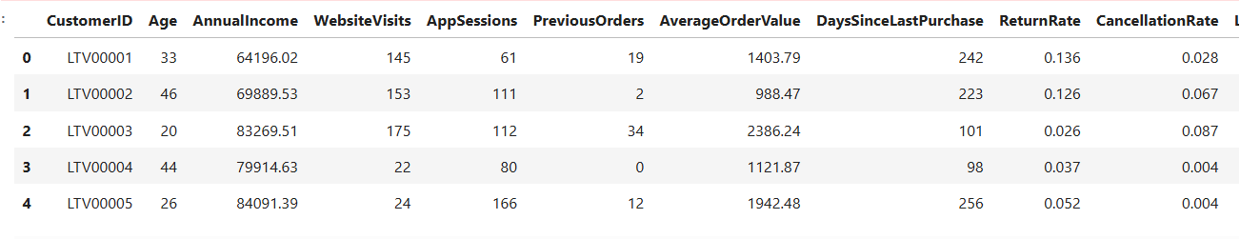
This is preview of first five rows.
STEP 5 – DATA CLEANING AND FEATURE ENGINEERING
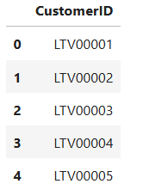
This table lists Customer IDs (LTV00001 to LTV00005), which uniquely identify each customer in your dataset. These IDs act as the foundation for segmentation, allowing you to connect customer behavior such as spending, orders, and engagement to business strategies.

STEP 6- EXPLORATORY DATA ANALYSIS
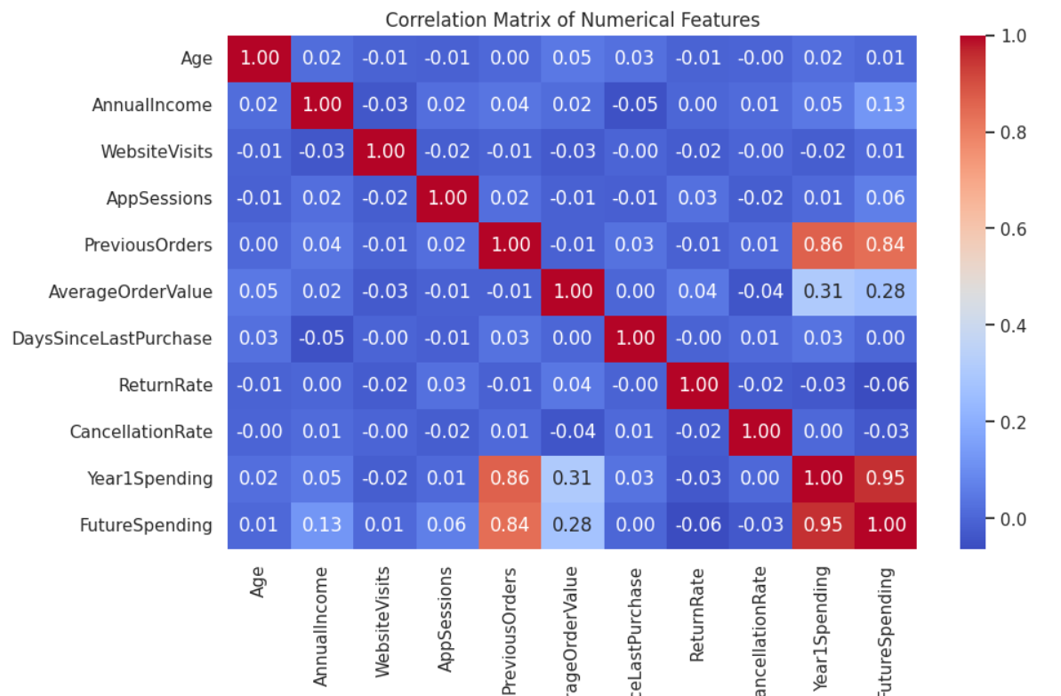
This image is a correlation matrix heatmap that shows how different numerical features in your dataset are related to each other. Strong positive correlations appear in red, while weaker or negative ones are closer to blue. For example, Previous Orders and Year1 Spending (0.86), and Year1 Spending with Future Spending (0.95) are highly correlated, meaning customers who spent more or ordered more in the past are very likely to spend more in the future.

